a)
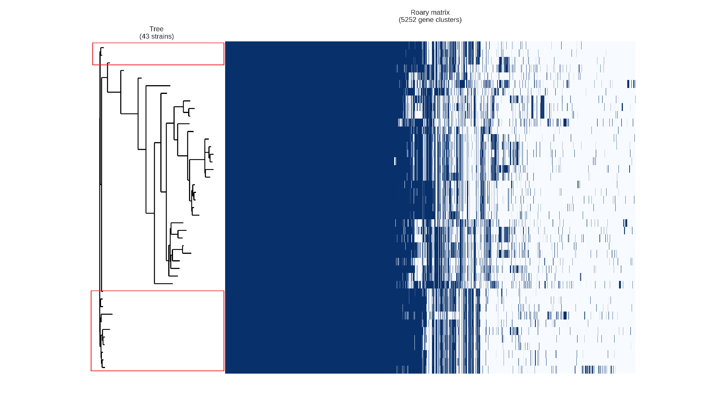
b)
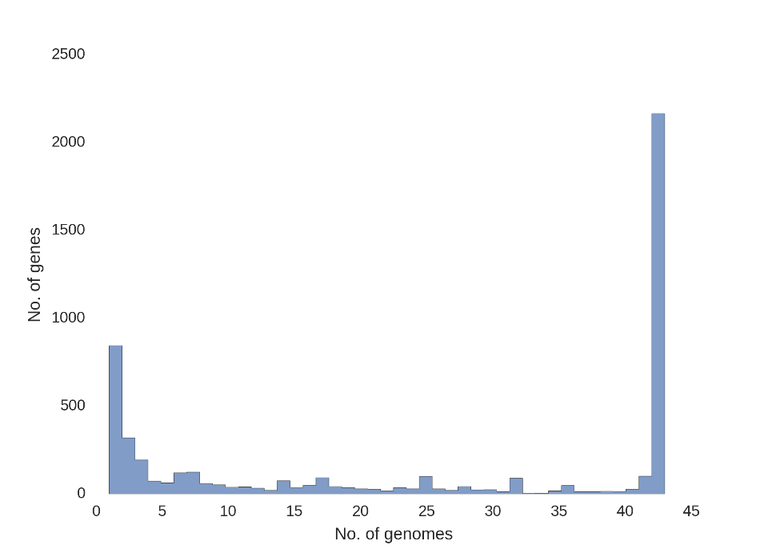
Fig. S3 Results of pangenome analysis of all ST117 strains (n=43) using roary_plots python script
a) Pangenome matrix (presence and absence of genes) of the individual strains, CT71 strains are marked in red
b) Frequency chart with the number of genes present in a given number of genomes; Left side of the x-axis shows the genes present in a single genome, right side of the x-axis shows the genes present in all genomes (n=43)

